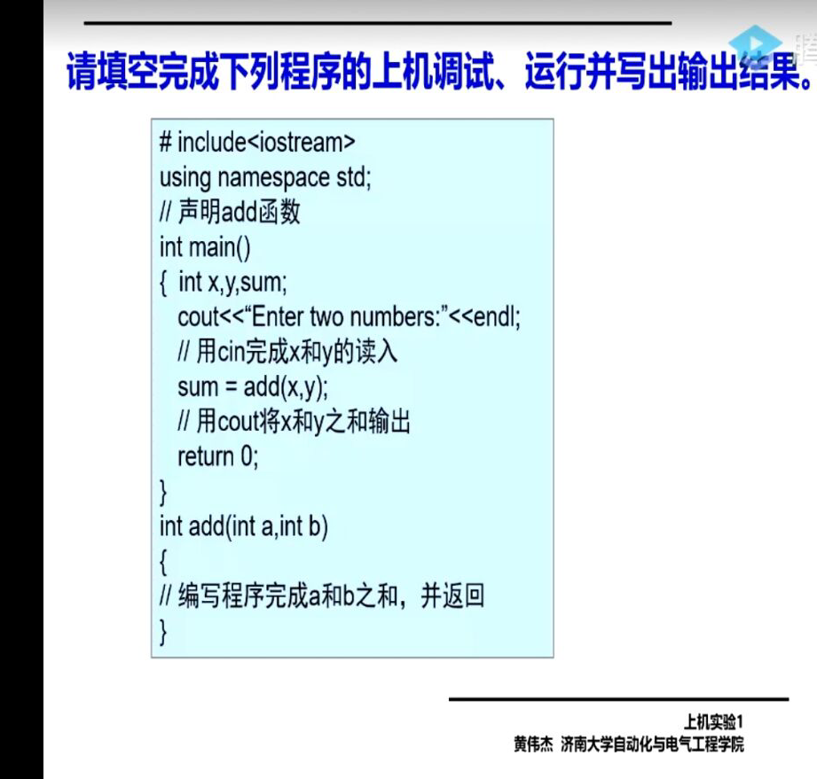

# include<iostream>

using namespace std;

int add(int a,int b)

{

return a+b;

}

int main()

{ int x,y,sum;

cout<<"Enter two numbers:"<<endl;

cin>>x>>y;

sum = add(x,y);

cout<<"ouput the sum "<<sum<<endl;

return 0;

}

# include<iostream>

using namespace std;

int main()

{

int age;

cout<<"Input your age:"<<endl;

cin>>age;

cout<<"Hello world I am "<<age<<endl;

system("pause") ;

return 0;

}

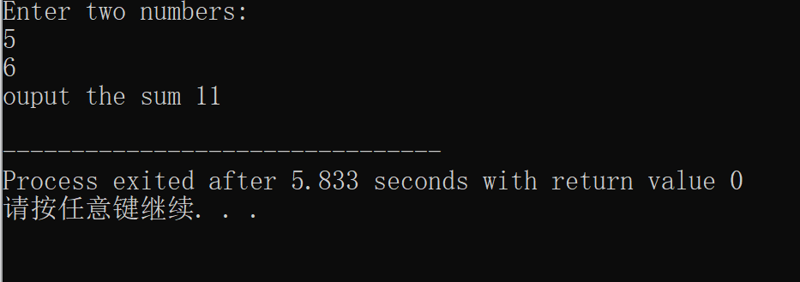

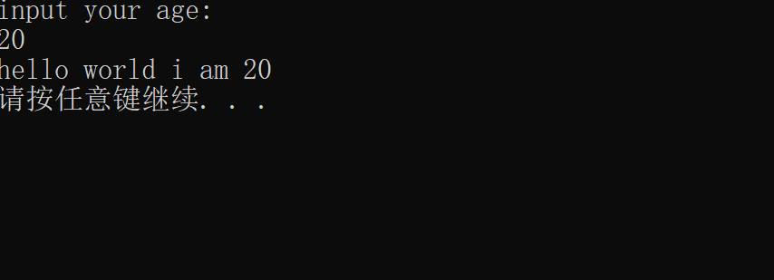

感想：

1、要注意c++： # include<iostream>

using namespace std;

而c语言：#include<stdio.h>,不能混用

2、声明函数后记得返回值return

3、c++输入输出用cin>> cout<< 注意箭头方向

4、endl是换行

Copyright ©2021-2099国家乐. All rights reserved